P.MOHITH..
AP25110010619…
LAB TASK 2….

GP CODE 1:

#include<stdio.h>
#include<math.h>

int main(){
int x,n,sum=0;
printf("Enter the value of x and n:");
scanf("%d %d",&x,&n);
sum=( x* (pow(x,n)-1)) / (x-1);
sum=sum+1;
printf("The sum of the values of gp upto n:%d",sum);
return 0;
}
OUTPUT:
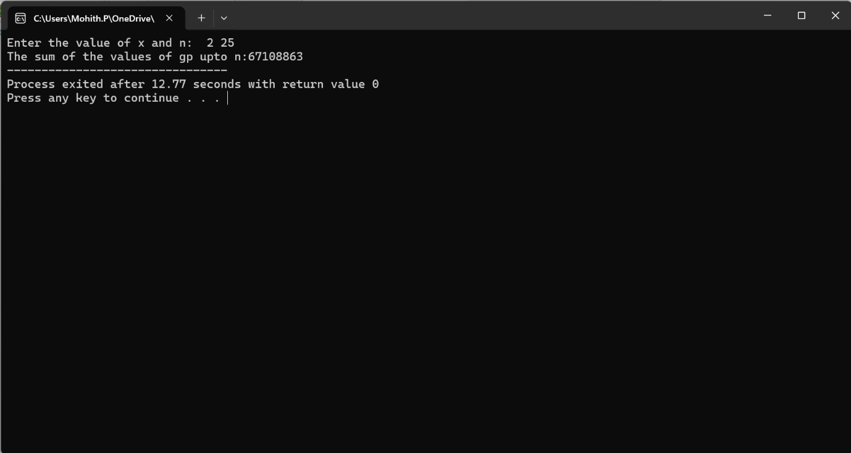
GP 2 CODE:
#include<stdio.h>
#include<math.h>

int main(){
int x,n,sum=0;
int i=1;
printf("Enter the value of x and n:");
scanf("%d %d",&x,&n);
for(i=0;i<=n;i++){
sum+=pow(x,i);
}
printf("The sum of the values of gp upto n:%d",sum);
return 0;
}

OUTPUT:
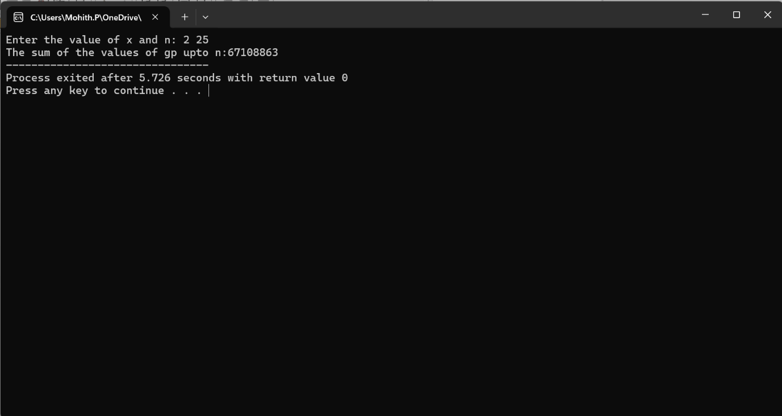

CODE FOR FINDING KTH SMALLEST:

#include <stdio.h>

void sortarr(int a[], int n) {
int i, j, temp;

for (i = 0; i < n - 1; i++) {
for (j = 0; j < n - i - 1; j++) {
if (a[j] > a[j + 1]) {
temp = a[j];
a[j] = a[j + 1];
a[j + 1] = temp;
}
}
}
}

int main() {
int n, i, k;

printf("Enter the size of the array: ");
scanf("%d", &n);

int a[n];

printf("Enter the elements:\n");
for (i = 0; i < n; i++) {
scanf("%d", &a[i]);
}

printf("Enter the value of k: ");
scanf("%d", &k);

if (k < 1 || k > n) {
printf("Invalid value of k");
return 0;
}

sortarr(a, n);

printf("The %dth smallest element is: %d", k, a[k - 1]);

return 0;
}

OUTPUT: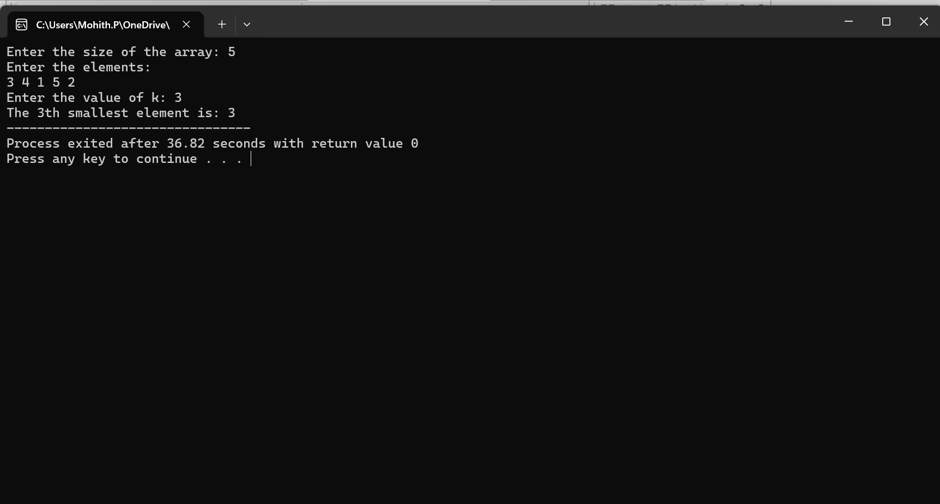

CODE FOR BST:

#include <stdio.h>
#include <stdlib.h>

struct node {
int data;
struct node *left;
struct node *right;
};

struct node* createNode(int value) {
struct node* newnode = (struct node*)malloc(sizeof(struct node));

newnode->data = value;
newnode->left = NULL;
newnode->right = NULL;

return newnode;
}

struct node* insert(struct node* root, int value) {

if (root == NULL) {
return createNode(value);
}

if (value < root->data) {
root->left = insert(root->left, value);
}
else if (value > root->data) {
root->right = insert(root->right, value);
}

return root;
}

struct node* findMin(struct node* root) {

while (root->left != NULL) {
root = root->left;
}

return root;
}

struct node* deleteNode(struct node* root, int value) {

if (root == NULL) {
return root;
}

if (value < root->data) {
root->left = deleteNode(root->left, value);
}
else if (value > root->data) {
root->right = deleteNode(root->right, value);
}
else {

if (root->left == NULL && root->right == NULL) {
free(root);
return NULL;
}

else if (root->left == NULL) {
struct node* temp = root->right;
free(root);
return temp;
}

else if (root->right == NULL) {
struct node* temp = root->left;
free(root);
return temp;
}

else {
struct node* temp = findMin(root->right);

root->data = temp->data;

root->right = deleteNode(root->right, temp->data);
}
}

return root;
}

void inorder(struct node* root) {

if (root != NULL) {
inorder(root->left);
printf("%d ", root->data);
inorder(root->right);
}
}

int main() {

struct node* root = NULL;
int n, value, deleteValue;

printf("Enter number of elements: ");
scanf("%d", &n);

printf("Enter elements:\n");

for (int i = 0; i < n; i++) {
scanf("%d", &value);
root = insert(root, value);
}

printf("Inorder before deletion: ");
inorder(root);

printf("\nEnter value to delete: ");
scanf("%d", &deleteValue);

root = deleteNode(root, deleteValue);

printf("Inorder after deletion: ");
inorder(root);

return 0;
}
OUTPUT:
